Ex6
import cv2
import matplotlib.pyplot as plt
from google.colab import files
import numpy as np
uploaded = files.upload()
filename = next(iter(uploaded))
img = cv2.imdecode(np.frombuffer(uploaded[filename], np.uint8), cv2.IMREAD_COLOR)
if img is None:
raise ValueError("Unable to read image.")
gray = cv2.cvtColor(img, cv2.COLOR_BGR2GRAY)
_, binary = cv2.threshold(gray, 127, 255, cv2.THRESH_BINARY)
kernel = np.ones((5, 5), np.uint8)
eroded = cv2.erode(binary, kernel, iterations=1)
plt.figure(figsize=(10, 4))
plt.subplot(1, 2, 1)
plt.imshow(binary, cmap="gray")
plt.title("Original Binary Image")
plt.axis("off")
plt.subplot(1, 2, 2)
plt.imshow(eroded, cmap="gray")
plt.title("Eroded Image")
plt.axis("off")
plt.show()

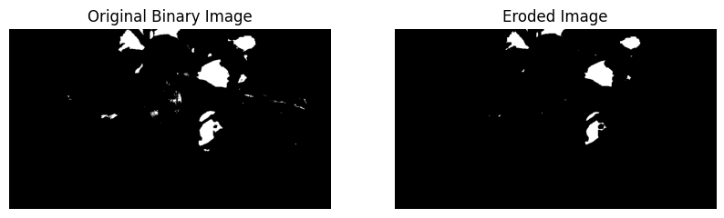

Ex7
import cv2
import time
from google.colab import files
from IPython.display import display, clear_output
from PIL import Image
import io
uploaded = files.upload()
filename = next(iter(uploaded))
with open(filename, "wb") as f:
f.write(uploaded[filename])
cap = cv2.VideoCapture(filename)
if not cap.isOpened():
raise ValueError("Unable to open video.")
fps = cap.get(cv2.CAP_PROP_FPS)
if not fps or fps <= 0:
fps = 25
def play_video(speed, title, max_frames=150):
cap.set(cv2.CAP_PROP_POS_FRAMES, 0)
count = 0
delay = 1.0 / (fps * speed)

print(title)
while cap.isOpened() and count < max_frames:
ret, frame = cap.read()
if not ret:
break
frame = cv2.cvtColor(frame, cv2.COLOR_BGR2RGB)
display(Image.fromarray(frame).resize((480, 270)))
time.sleep(delay)
clear_output(wait=True)
count += 1
print(title, "finished.")
play_video(1, "Normal Speed")
play_video(0.5, "Slow Motion")
play_video(2, "Fast Motion")
cap.release()

Fast Motion finished.
Ex8

import cv2
import matplotlib.pyplot as plt
from google.colab import files
import numpy as np
uploaded = files.upload()
filename = next(iter(uploaded))
img = cv2.imdecode(np.frombuffer(uploaded[filename], np.uint8), cv2.IMREAD_COLOR)
if img is None:
raise ValueError("Unable to read image.")
gray = cv2.cvtColor(img, cv2.COLOR_BGR2GRAY)
_, binary = cv2.threshold(gray, 127, 255, cv2.THRESH_BINARY)
kernel = np.ones((5, 5), np.uint8)
dilated = cv2.dilate(binary, kernel, iterations=1)
plt.figure(figsize=(10, 4))
plt.subplot(1, 2, 1)
plt.imshow(binary, cmap="gray")
plt.title("Original Binary Image")
plt.axis("off")
plt.subplot(1, 2, 2)
plt.imshow(dilated, cmap="gray")
plt.title("Dilated Image")
plt.axis("off")
plt.show()

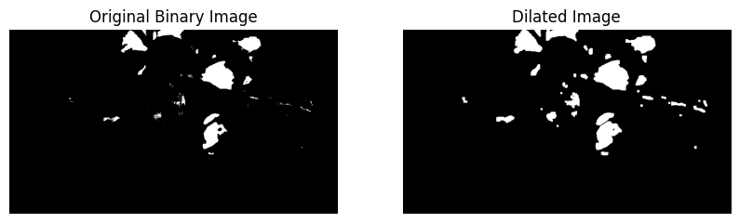

Ex9

import cv2
import matplotlib.pyplot as plt
from google.colab import files
import numpy as np
uploaded = files.upload()
filename = next(iter(uploaded))
img = cv2.imdecode(np.frombuffer(uploaded[filename], np.uint8), cv2.IMREAD_COLOR)
if img is None:
raise ValueError("Unable to read image.")
h, w = img.shape[:2]
bigger = cv2.resize(img, (w * 2, h * 2), interpolation=cv2.INTER_CUBIC)
smaller = cv2.resize(img, (max(1, w // 2), max(1, h // 2)),
interpolation=cv2.INTER_AREA)
images = [img, bigger, smaller]
titles = ["Original", "Bigger (2x)", "Smaller (0.5x)"]
plt.figure(figsize=(12, 5))
for i, (image, title) in enumerate(zip(images, titles), 1):
plt.subplot(1, 3, i)
plt.imshow(cv2.cvtColor(image, cv2.COLOR_BGR2RGB))
plt.title(title)
plt.axis("off")
plt.tight_layout()
plt.show()

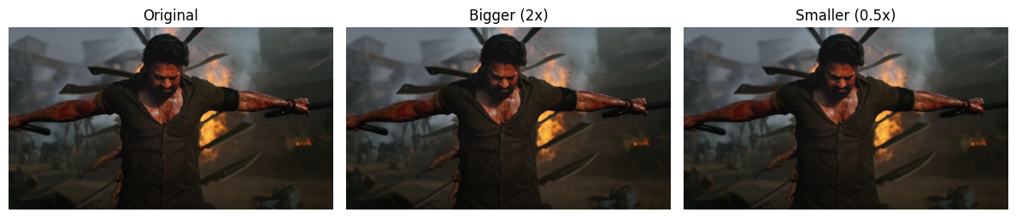

Ex10

import cv2
import matplotlib.pyplot as plt
from google.colab import files
import numpy as np
uploaded = files.upload()
filename = next(iter(uploaded))
img = cv2.imdecode(np.frombuffer(uploaded[filename], np.uint8), cv2.IMREAD_COLOR)

if img is None:
raise ValueError("Unable to read image.")
rotated = cv2.rotate(img, cv2.ROTATE_90_CLOCKWISE)
plt.figure(figsize=(10, 4))
plt.subplot(1, 2, 1)
plt.imshow(cv2.cvtColor(img, cv2.COLOR_BGR2RGB))
plt.title("Original")
plt.axis("off")
plt.subplot(1, 2, 2)
plt.imshow(cv2.cvtColor(rotated, cv2.COLOR_BGR2RGB))
plt.title("90 Degrees Clockwise")
plt.axis("off")
plt.show()

